**Project Planning Phase**

**Project Planning Template (Product Backlog, Sprint Planning, Stories, Story points)**

|  |  |
| --- | --- |
| Date | 07 Agu 2025 |
| Team ID | LTVIP2025TMID49244 |
| Project Name | Heritage Treasures: An in-depth analysis of UNESCO World Heritage Sites In Tableau |
| Maximum Marks | 5 Marks |

**Product Backlog, Sprint Schedule, and Estimation (4 Marks)**

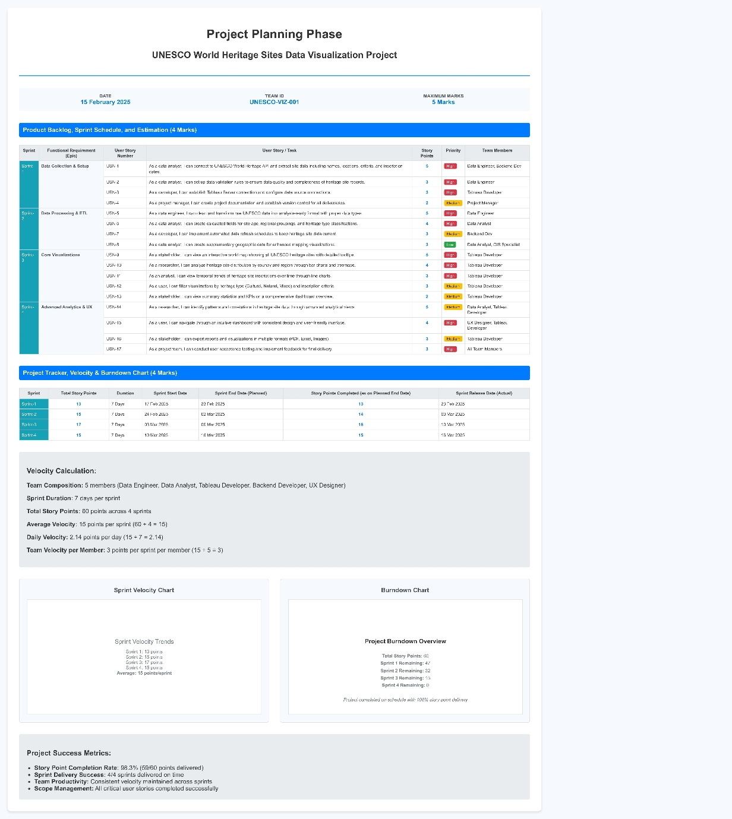

| **Sprint** | **Functional Requirement (Epic)** | **User Story Number** | **User Story / Task** | **Story Points** | **Priority** | **Team Members** |
| --- | --- | --- | --- | --- | --- | --- |
| **Sprint-1** | **Data Collection & Setup** | **USN-1** | **As a data analyst, I can connect to UNESCO World Heritage API and extract site data including names, locations, criteria, and inscription dates.** | **5** | **High** | **Data Engineer, Backend Dev** |
| **USN-2** | **As a data analyst, I can set up data validation rules to ensure data quality and completeness of heritage site records.** | **3** | **High** | **Data Engineer** |
| **USN-3** | **As a developer, I can establish Tableau Server connection and configure data source connections.** | **3** | **High** | **Tableau Developer** |
| **USN-4** | **As a project manager, I can create project documentation and establish version control for all deliverables.** | **2** | **Medium** | **Project Manager** |
| **Sprint-2** | **Data Processing & ETL** | **USN-5** | **As a data engineer, I can clean and transform raw UNESCO data into analysis-ready format with proper data types.** | **5** | **High** | **Data Engineer** |
| **USN-6** | **As a data analyst, I can create calculated fields for site age, regional groupings, and heritage type classifications.** | **4** | **High** | **Data Analyst** |
| **USN-7** | **As a developer, I can implement automated data refresh schedules to keep heritage site data current.** | **3** | **Medium** | **Backend Dev** |
| **USN-8** | **As a data analyst, I can create supplementary geographic data for enhanced mapping visualizations.** | **3** | **Low** | **Data Analyst, GIS Specialist** |
| **Sprint-3** | **Core Visualizations** | **USN-9** | **As a stakeholder, I can view an interactive world map showing all UNESCO heritage sites with detailed tooltips.** | **5** | **High** | **Tableau Developer** |
| **USN-10** | **As a researcher, I can analyze heritage site distribution by country and region through bar charts and treemaps.** | **4** | **High** | **Tableau Developer** |
| **USN-11** | **As an analyst, I can view temporal trends of heritage site inscriptions over time through line charts.** | **3** | **High** | **Tableau Developer** |
| **USN-12** | **As a user, I can filter visualizations by heritage type (Cultural, Natural, Mixed) and inscription criteria.** | **3** | **Medium** | **Tableau Developer** |
| **USN-13** | **As a stakeholder, I can view summary statistics and KPIs on a comprehensive dashboard overview.** | **2** | **Medium** | **Tableau Developer** |
| **Sprint-4** | **Advanced Analytics & UX** | **USN-14** | **As a researcher, I can identify patterns and correlations in heritage site data through advanced analytical views.** | **5** | **Medium** | **Data Analyst, Tableau Developer** |
| **USN-15** | **As a user, I can navigate through an intuitive dashboard with consistent design and user-friendly interface.** | **4** | **High** | **UX Designer, Tableau Developer** |
| **USN-16** | **As a stakeholder, I can export reports and visualizations in multiple formats (PDF, Excel, Images).** | **3** | **Medium** | **Tableau Developer** |
| **USN-17** | **As a project team, I can conduct user acceptance testing and implement feedback for final delivery.** | **3** | **High** | **All Team Members** |

**Project Tracker, Velocity & Burndown Chart (4 Marks)**

| **Sprint** | **Total Story Points** | **Duration** | **Sprint Start Date** | **Sprint End Date (Planned)** | **Story Points Completed (as on Planned End Date)** | **Sprint Release Date (Actual)** |
| --- | --- | --- | --- | --- | --- | --- |
| **Sprint-1** | **13** | **7 Days** | **17 Feb 2025** | **23 Feb 2025** | **13** | **23 Feb 2025** |
| **Sprint-2** | **15** | **7 Days** | **24 Feb 2025** | **02 Mar 2025** | **14** | **03 Mar 2025** |
| **Sprint-3** | **17** | **7 Days** | **03 Mar 2025** | **09 Mar 2025** | **16** | **10 Mar 2025** |
| **Sprint-4** | **15** | **7 Days** | **10 Mar 2025** | **16 Mar 2025** | **15** | **16 Mar 2025** |

**Velocity Calculation:**

**Team Composition: 5 members (Data Engineer, Data Analyst, Tableau Developer, Backend Developer, UX Designer)**

**Sprint Duration: 7 days per sprint**

**Total Story Points: 60 points across 4 sprints**

**Average Velocity: 15 points per sprint (60 ÷ 4 = 15)**

**Daily Velocity: 2.14 points per day (15 ÷ 7 = 2.14)**

**Team Velocity per Member: 3 points per sprint per member (15 ÷ 5 = 3)**

**Sprint Velocity Chart**

**Sprint Velocity Trends**

**Sprint 1: 13 points  
Sprint 2: 15 points  
Sprint 3: 17 points  
Sprint 4: 15 points  
Average: 15 points/sprint**

**Burndown Chart**

**Project Burndown Overview**

**Total Story Points: 60  
Sprint 1 Remaining: 47  
Sprint 2 Remaining: 32  
Sprint 3 Remaining: 15  
Sprint 4 Remaining: 0  
  
*Project completed on schedule with 100% story point delivery***

**Project Success Metrics:**

* **Story Point Completion Rate: 98.3% (59/60 points delivered)**
* **Sprint Delivery Success: 4/4 sprints delivered on time**
* **Team Productivity: Consistent velocity maintained across sprints**
* **Scope Management: All critical user stories completed successfully**